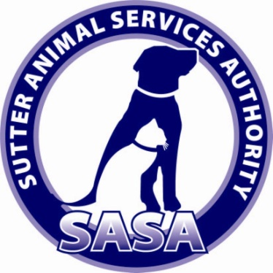
Friends
Of the
Sutter Animal Services Authority

APPLICATION FOR APPOINTMENT TO
Friends of SASA, 501c3 Non-Profit
Organization

Dear Volunteer,
Thank you for your interest in the Friends of SASA Board of Directors.

The Board of Directors is an all-volunteer organization. Our purpose is to assist and support animal services, facility and programs in Sutter County. Our mission is to accept donations, and solicit, raise, distribute and assist in management of public and private sector funds for the enhancement of animal services and programs for the express benefit of improving the quality of life for all animals in Sutter County.

We are seeking board members that are responsible, compassionate and committed and who truly want to make a difference in the lives of homeless animals.

It is important for all applicants to realize that a completed Volunteer Application does not guarantee placement in our organization. All applications are reviewed and whether to place an applicant in the organization is solely at the discretion of our organization.

We would like to get to know you and your skills better. The information you share here will help us select and maintain a Board with diverse skills and experiences.

On behalf of the entire Board of Directors we look forward to hearing from you.

Regards,
Helen Asher
President, Friends of SASA

______________________________________________________________________________
Friends of SASA-Board of Directors Page 1

Date:_____________

First Name____________________________Last Name_______________________________

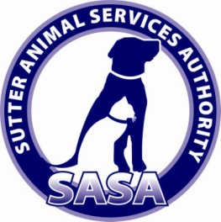
Address________________________________________________________________________

City______________________________County_______________State______Zip__________

Home Phone_________________________Cell Phone__________________________________

Email Address___________________________________________________________________

Employer_______________________________________________________________________

Position Held______________________________Work Phone___________________________

Employer Address________________________________________________________________

Memberships in other organizations: (please list name of organization, city and state of
organization and position held within the organization)

1.
2.
3.

If appointed, are you willing to attend quarterly board meetings? Yes No
If appointed, are you willing to serve additional hours as needed for
committee meetings/events? Yes No

Why are you interested in serving on the Friends of SASA Board of Directors?

______________________________________________________________________________________
Friends of SASA-Board of Directors Page 2

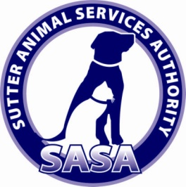

What is your definition of a good board member?

Please list previous experience in, or with non-profit organizations. What were your major contributions to their mission?

What qualifications do you have that would be beneficial to this Board of Directors?

What do you believe is the responsibility of an Animal Shelter Program to the Community?

Please return completed application to:
Friends of SASA
200 Garden Highway
Yuba City, CA 95991
Or
Email to:
Friendsofsasa@gmail.com

______________________________________________________________________________________
Friends of SASA-Board of Directors Page 3

